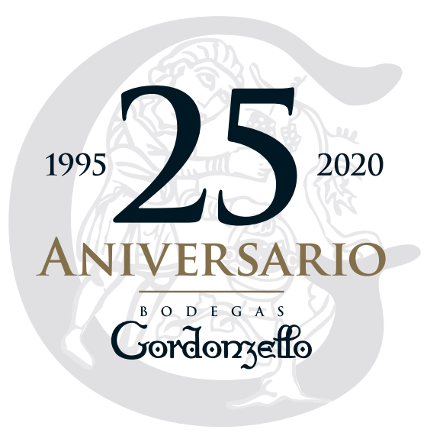
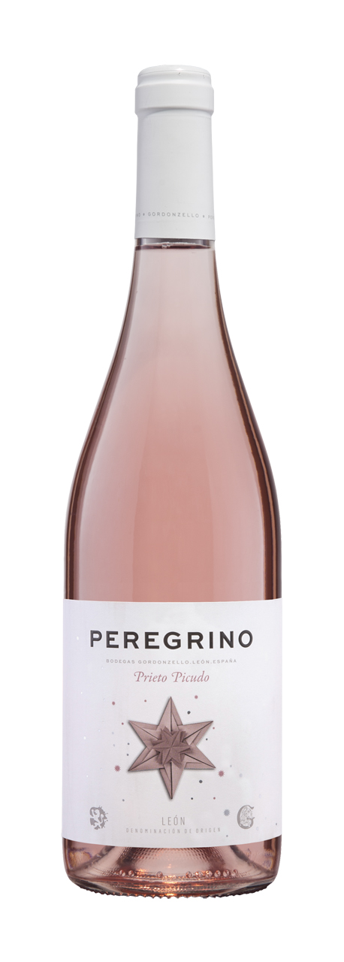

Variety: 100 % Prieto Picudo from our vineyards in Gordoncillo (León; Castilla y León) Spain.
Ground type: Clay soil

Appellation of origin: D. O. León
Winemaking process: Mechanical night harvest (to preserve freshness of the grape), cold maceration around 8ºC during few hours, we work the lees in the must before alcoholic fermentation controlled in stainless steel vats.
Ageing: Young unoaked
Style: Rosé wine
Tasting note: Brilliant and clean rosé wine. The color is rosé blush with the attractive blue-purple glints appear. Medium aromatic intensity on the nose, we can find fruity aromas as peach skin and florals with reminds of rose water perfume. In mouthfeel it is characterized by the persistent and its pleasant acidity. It´s freshness invite us to the taste it repeatedly.

Serving Temperature: 5 ºC to 8ºC

